1. Shut down the Raspberry Pi

2. Take the MicroSD card out of the pi, insert it into a microSD card reader, and put it into a Windows computer.

3. You should get the following message. DO NOT CLICK FORMAT. Click cancel

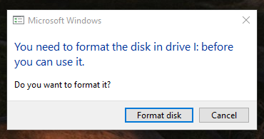

4. Download Win32 Disk Imager from https://sourceforge.net/projects/win32diskimager/files/latest/download

5. You can click next until you are through the install for Win32 Disk Imager

6. Once Win32 Disk Imager launches, you should see this screen:

